Upload image through se78

1. Keep a bitmap image on ur desktop

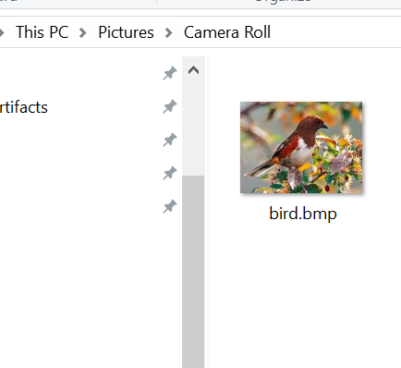

1. Go to tcode Se78

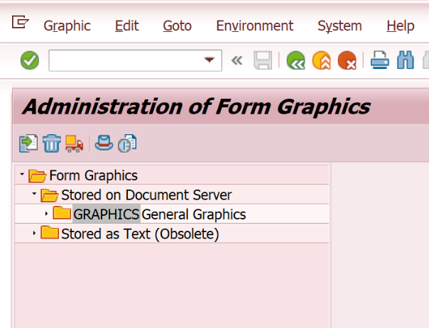

1. Click on import button at extreme left.

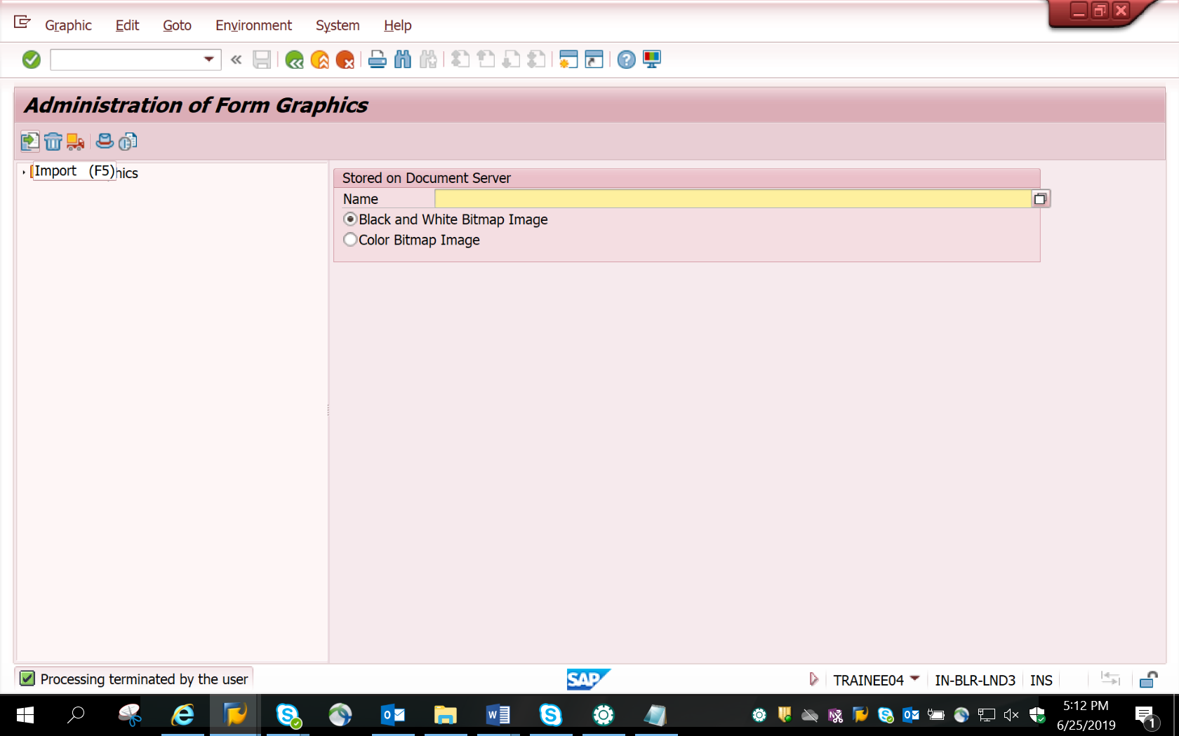

1. Below screen appears

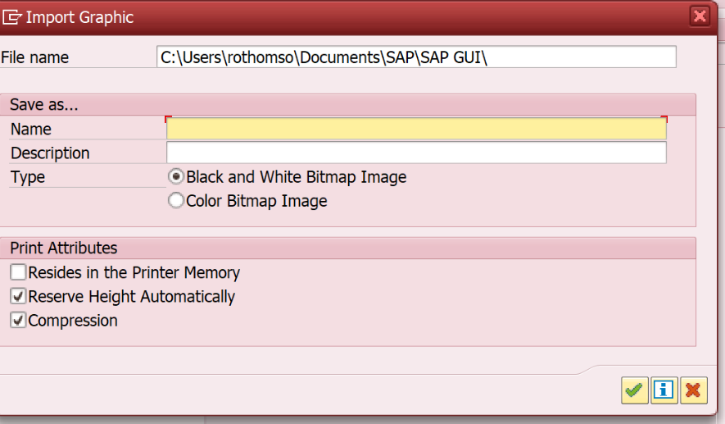

1. Browse image from the local desktop. Give the file path and any name and description.

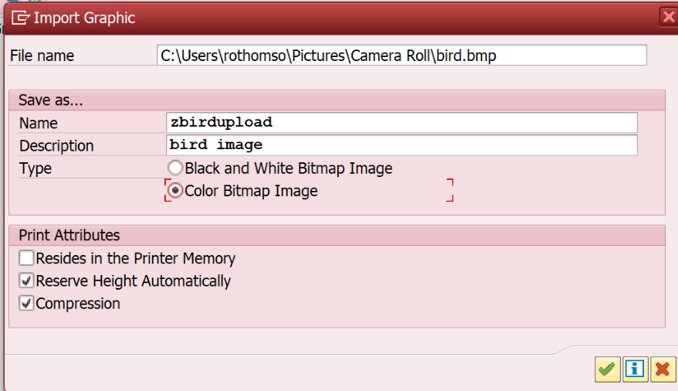

1. The green success message at the bottom indicates image was loaded from desktop to SAP.

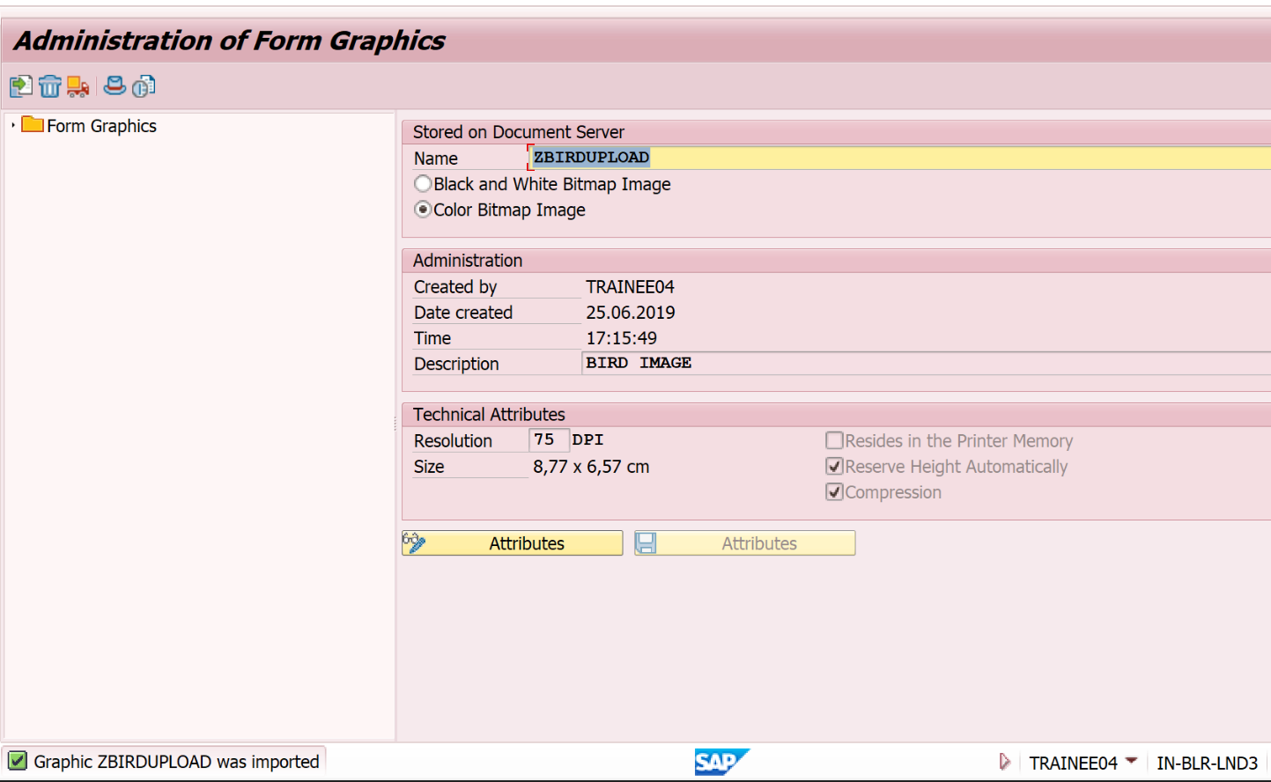

The name of the uploaded image is ZBirdupload.